Fashionable New York City: Girls’ American Dream, American Girls’ Dream, Dream Girls’ America?

Kulcsár Zsófia

Abstract: More and more films are aimed at a young female audience. These movies are usually about a young, single, and ambitious career woman who moves to a big city in order to fulfill her dream of becoming successful. The story is almost always located in big cities like New York, however, apart from mentioning that these characters are “urban girls”, in the scholarly analysis of these movies the city rarely comes up as a significant factor in forming the characters’ identity. Therefore, my goal is to understand what hopes and opportunities the City creates for the main character and how/whether the representation of the city in these movies contributes to the ‘chick flick’ genre.
Keywords: fashion, post-feminism, chick-flick

Introduction

Nowadays, more and more films are aimed at the female audience, especially in the ‘chick flick’ genre. These films are mostly about a young, middle-class, white woman who moves to a big city trying to fulfill her dream of having a great career and finding a male partner. The story is almost always located in big cities like New York City, however, apart from mentioning in the scholarly analysis of these movies that these characters are ’urban women’; the city rarely comes up as major factor in forming the characters identity. Examples for this genre could be the Sex and the City (1998-2004), Bridget Jones Diary (2001- 2004), Maid in Manhattan (2002), Legally Blonde (2001), The Devil Wears Prada (2006), etc.
In my opinion, in ‘chick flicks’ the urban location has a leading role in defining the character’s identity. ‘Chick flicks’ have a certain way of producing an image of the urban space which is closely connected to what we could call as the “consumer space.” In my paper - with the help of feminist theorization of consumer culture and fashion - I intend to focus on how cities are represented in these movies. I will analyze The Devil Wears Prada (2006) in more detail to understand what big cities, in this case New York City, mean to an ambitious young woman like the main character in The Devil Wears Prada.

Women in/and public space

The city has always been seen as a man-made environment, what’s more, urban planning and architecture as professions have been dominated by men. According to Dolores Hayden the idea that “woman's place is in the home” has been one of the most important principles of architectural design and urban planning in the United States for the last century. (Hayden 170)

Dwellings, neighborhoods, and cities designed for homebound women constrain women physically, socially, and economically. Acute frustration occurs when women defy these constraints to spend all or part of the work day in the paid labor force. (Hayden 171)

Judy Wajcman examines the development of the home from the Victorian era until the 1990s and argues that houses reflect domestic ideals of appropriate spheres for male and female activity. “Sexual divisions are literally built into houses and indeed the whole structure of the urban system.” (Wajcman 110) She also argues that most cities were geographically divided in a way that it served men’s needs; they were divided into masculine cities and feminine suburbs. For example, home and neighborhood were considered to be the location for women, accordingly, the main function of public transport was to get men from home and back again. Because of this division of spaces women were tied to their immediate locality (Wajcman 197).
Therefore, the city space is not merely a neutral context for people and for urban structures. Both the lived and the imagined space of the city have a significant role in the formation of gender and sexual identities. Although much have changed since the two above mentioned authors described the city space as gendered, as by the 2000s women are entering the public space more and more, we can still say that the city space is rather a masculine space. So what happens when a young woman enters this space? What hopes and opportunities does the City create for women in these movies?

City as a Consumer Space

These days the urban environment in the US offers financial and personal opportunities not only for men but also for women. One of the major attributes of the ‘chick flick’ genre is that the story is almost always located in big cities like New York. New York City is the location where young women can fulfill their dreams, in other words, today the City is the place where young women’s fairytale takes place. New York City is represented not only as a financial or business centre but also as a place for consumer culture, fashion and entertainment.
In ‘chick flicks’ the main character is a young, heterosexual, single, and educated woman who seems to be a powerful subject since she has a rewarding job which allows her to be financially independent. However, her power mostly lies in being able to participate in consumer culture. Such representation is described as post-feminist by the following authors: Angela McRobbie (2009), Rosalind Gill (2007), Ann Brooks (1997), or ‘neo-feminism’ by Hilary Radner (2011). These scholars focus on the role of consumer culture and fashion in contemporary (popular) culture. They argue that contemporary popular culture represents a post-feminist, sexually active, consumerist, fashionable femininity, however, they claim that this ‘new’ femininity is not as liberating as it seems to be.
Hilary Radner, in her book Neo-Feminist Cinema: Girly Films, Chick Flicks, and Consumer Culture analyzes contemporary American ‘girly films’ and ‘chick flicks’. Radner argues that besides the emphasis on consumer culture and fashion, romance is also a significant factor in these movies. Radner proposes to use the term ‘neo-feminism’

to refer to the tendency in feminine culture to evoke choice and the development of individual agency as the defining tenets of feminine identity – best realized through an engagement with consumer culture in which the woman is encouraged to achieve self-fulfillment by purchasing, adorning or surrounding herself with the goods that this culture can offer. (Radner 6)

Radner explores the ways in which fashion industry made use of the media throughout the past couple of decades. HBO with the TV series Sex and the City had a great influence on what is called the contemporary ‘fashion film’. Radner analyses the film called The Devil Wears Prada (2006) and identifies it as a ‘fashion film’. She considers ‘fashion films’ as the contemporary form of costume display since clothing itself becomes the object of the spectators’ gaze (Radner 136). According to Radner, Hollywood generated an interest in fashion with which it supports the neo-feminist agenda (Radner 142). The production of such movies are highly supported by the fashion industry, therefore, the fashion film’s goal is to gain media attention and to advertise fashionable clothes through these films. Radner also claimed that fashion industry was not the only supporter of the production of movies in New York but film-television tax incentives were also sponsored by the New York State Legislature and the city of New York (Radner 144). Some tourists made New York City their destination just because the movie was produced there and they wanted to see the production. Thus, the shooting of Sex and the City was seducing tourists to the location and there were loads of paparazzi and tourist photos made (Radner 160). Radner mentions Sarah Jessica Parker’s comment on HBO’s Sex and the City who claims that “New York was the greatest character ever written.” (Radner 145). Parker’s famous, much quoted sentence is very telling. It highlights the significance of the City, allowing us to see how a producer chooses the setting and opens up a new perspective on how cities in the genre of the ‘chick flick’ should be considered. Moreover, I found a different interview where she stated that “(s)he is the fifth lady” in the movie, meaning that New York is the fifth lady in the movie, which is I think an even more telling comment on the way the City is meant to be depicted. Parker suggests that the city is a separate character with its own identity.

Analysis: ’The Devil Wears Prada’

The Devil Wears Prada (2006) is the adaptation of the novel of the same title written by Lauren Weisberger in 2003. Weisberger’s is a successful novel. It is said to be based on a true story about the author’s own experience of being an assistant of Anna Wintour who is the famous editor of the prestigious fashion magazine, Vogue.
I chose to analyze this movie because I think it is a very good example for contemporary post-feminist or as Radner calls neo-feminist movies. It contains many attributes of the ‘chick flick’ genre including the presence of consumer culture and fashion, not to mention the significance of the romance in the story. Moreover, urban environment as a setting also has a significant role in forming the (main) character’s identity.
The movie is about a young woman called Andy (played by Anne Hathaway) who had just graduated as a journalist at a small town college and moves to New York with the hope of finding a job. In the beginning, the movie basically depicts the fantasy about life in New York dreamed up by people, but in this case especially by young women. New York is represented as a fairytale location for young women, as an ideal place for young women to live and work at. Andy’s ambitions could be regarded as the contemporary “girly” version of the American Dream: young woman goes to New York City in order to have opportunity for prosperity and success. New York (still) represents hope for young people, however, not only for men, but also for ambitious women like the main character of this movie.
In the beginning when Andy is looking for a job she aspires to be a journalist at a “serious” paper. She is highly critical of popular culture and fashion. After many attempts of trying to find a job as a journalist, she is offered a position as an assistant to the demanding editor (played by Meryl Streep) of a prestigious fashion magazine called Runway. In the beginning she does not realize how lucky she is by getting the job that all the girls would dream of, but her colleagues do not fail to inform her: “a million girls would kill for that job.” Andy is represented both as critical and as naive in the beginning. On the one hand she does not seem to be interested in fashion, what’s more, she is highly critical of it, but on the other hand, she does not have any idea of the big city “elite lifestyle” at all.
However, as time passes she goes through a self-transformation. Since initially Andy is not in the know of what (elite) fashion is, she is constantly ridiculed by her boss and colleagues because of her untrendy way of dressing and her messy hairstyle. After a while, in order to impress her boss she decides to change her look and begins to dress in a more stylish way. From this on, the narrative puts on the attributes of what we could call a “post-feminist coming-of-age story”: with the transformation in her look comes the transformation in her working skills; with a better look she does her job more successfully and she begins to like it. As Angela McRobbie suggests, this is a very typical characteristic of post-feminist narratives: women need to go through self-improvement by the means of consuming products like fashion clothes and beauty items as well as various services of self-care, which makes ‘femininity’ seem as matter of consumption (McRobbie 19). Moreover, clothing is made to seem as a free choice for Andy that she chose willingly and with the help of fashion her life was changed for the better.
However, in the meanwhile her relationship with her boyfriend and friends changes and they start to dislike her “new identity”. In the end, she makes a decision that is represented as an adult decision: in order to save her relationship with her boyfriend, she gives up her job at the Runway, in spite of the fact that in the end she started to find it fulfilling, exciting and challenging. The role of her boss, who is the editor of the magazine, is also very important because Andy gives up her job “realizing” that her boss is unhappy by being an ambitious career woman and for not having time for her family. In the end, Andy finds new job that is not so time-consuming. Although she gives up wearing elite fashion clothing, her attitude to fashion is still the same, she is still represented as a fashionable, self-confident young woman.
On the whole, we can say that the film raises questions such as how far will Andy go to get what she wants? Will she choose to live her own dreams? Sad as it is, the movie sticks to the post-feminist idea that women have to choose between career and romance. They simply cannot have both, it’s either one or the other, but happiness will only come with romance. Ambitious career women like Andy’s boss are represented as unhappy, frustrated and even mean when it comes to making business decisions.

Fashion and the City in the movie

New York is known for its role of influencing the world’s taste in fashion, what’s more, fashion industry has one of its centers in New York. Therefore, the location has a significant role in the movie. The city has similar role as fashion items, they both become accessories to the main character’s identity, clothing is the object of the spectators’ gaze just as much as the City.
Right in the beginning of the movie we can recognize New York City from all its skyscrapers, yellow cabs and well-known locations. The skyscrapers are signs of the financial and business centers in New York; therefore, they are symbols of capitalism in the movie as well. The skyscrapers are shown from time to time and these settings make New York City clearly recognizable.
Although New York has been the symbol of masculinity and wealth in mainstream movies, in the ‘chick flick’ genre the city seems to have a different meaning. When it comes to chick flicks, the city is mostly represented as a consumer space. At the time when Andy arrives to New York, she is not yet stylish or trendy enough to fit into the cosmopolitan lifestyle. Because of her unfashionable way dressing before working for Runway, she is represented as if she looked out of place, as if she would not fit in the glamorous landscape of the City.
In the movie the streets of New York are functioning as catwalks themselves serving the fashion industry. The streets are frequently used to show the main character in her fashionable dresses and with this the movie becomes a marketing space for elite fashion items. Andy walks on New York’s busy streets wearing her brand new fashionable clothes just as if she was in a fashion show. She is constantly redressed during the film to display these elite fashion clothes. In this sense, characters in The Devil Wears Prada fulfill the function of a mannequin, however, in the setting of New York’s elegant milieu.
Radner claims that fashion in films such as The Devil Wears Prada fulfills the same function as the fashion show “but within an even broader, more popular context and with the fuller range of affect that cinema provides as an individual and social experience—as an event that is both lived through and talked about” (Radner 151). By this she is saying that the genre of the fashion film democratizes fashion at least in a way that elite fashion is no more bound to the elite Fashion Shows but “ideas” of high fashion are available for a wider public for discussion.
The City is represented as a major location for consumer culture; Andy is always carrying around a shopping bag with the brand or logo of elite fashion clothes on it. Another very typical scene in the movie is when Andy is carrying coffee in take-away paper cups from Starbucks to her workplace. There is a recognizable logo of Starbucks Coffee Company on these paper cups, Starbucks is the largest and probably the most well-known coffeehouse company in the world. The setting’s goal is to emphasize New York’s consumerist lifestyle while the movie is also a marketing space itself.
On the other hand, New York City is more than a just shop window in this movie. The movie captured the pulse of the cosmopolitan lifestyle and the (elite) fashion industry. New York is represented as an inspiring environment which leads to new ideas in fashion. The movie captured the glamour and excitement of living in New York. Andy is not represented as a traditional housewife, instead of preparing food herself she is eating out. She is always running from one location to the other on New York’s busy streets while she is constantly on the phone. We can feel the pulse of the city; cars and yellow cabs are always around and we can repeatedly hear the stressing sound of the horn whenever Andy wants to cross the street. Nevertheless, the city is represented as busy and exciting, rather safe than dangerous, there is never a concern of the danger of being hurt, robbed or raped.
There are visible differences between the representation of New York City and Paris in the movie. The team from the Runway fashion magazine, including the editor and the main character, Andy, travels to Paris for a Fashion Week to participate in the annual fashion show, where fashion designers meet and display their latest collections. When they arrive to Paris we can feel that the story and the characters slow down. There is no vibe and rush in Paris, no horns etc. Although Paris is a huge city and it is another centre for the fashion industry, we still cannot feel the constant rushing of the story and the characters there. Paris has a completely different milieu and with its calmness it is in contrast with New York City.

Conclusion

In my paper I highlighted the role the location itself plays in ‘chick flicks’. New York City lifestyle is still appreciated and pretty much wanted by the main character. It is represented as a busy, exciting and ideal location for young women to live and work at. The City offers young women the opportunity to fulfill their dreams. However, this lifestyle in Andy’s case was only made to seem appealing until she realized it affected her relationship with her boyfriend. Therefore, this is a typical post-feminist coming-of-age narrative of girls fulfilling the requirements of traditional femininity and choosing romance over their career.
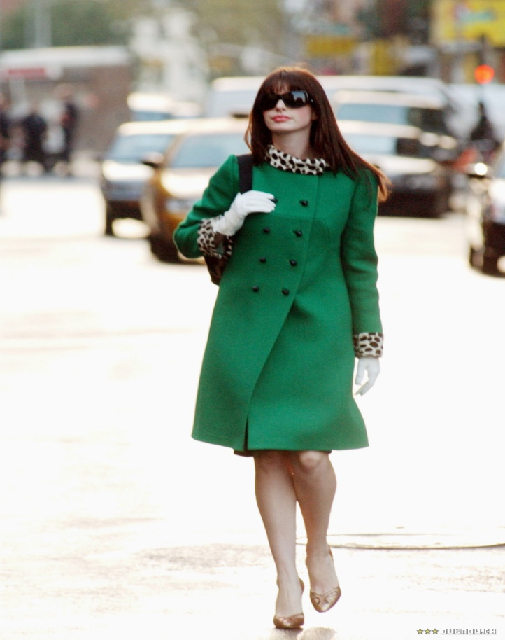
Source: http://couturediaries.webs.com/apps/blog/show/4918370 Available: 9.01.2014

Works Cited

Brooks, Ann. 1997. Post feminisms: Feminism, Cultural Theory and Cultural Forms. London and New York: Routledge.
Frankel, David. 2006. The Devil Wears Prada, The movie.
Hayden, Dolores. 1980. “What Would a Non-Sexist City Be Like? Speculations on Housing, Urban Design, and Human Work”. Signs, Vol. 5, No. 3. The University of Chicago Press. pp.170-187.
McRobbie, Angela. 2009. The Aftermath of Feminism: Gender, Culture and Social Change. London: Sage.
Radner, Hilary.2011. Neo-Feminist Cinema: Girly Films, Chick Flicks and Consumer Culture. Taylor & Francis. Kindle Edition.
Rosalind, Gill. 2007. “Postfeminist Media Culture, Elements of a Sensibility,” European Journal of Cultural Studies 10, no. 2 147–66, http://eprints.lse.ac.uk/2449/
Wajcman, Judy.1991. Feminism confronts technology. Polity Press, Cambridge, UK.
Weisberger, Lauren. 2003. The Devil Wears Prada, Broadway Books, New York.

Zsófia Kulcsár has been studying in the ’English and American Literature and Culture’ PhD program in Szeged, Hungary since 2011. She earned her BA degree in English Studies and German Studies at the University of Szeged in 2009 and continued her studies in the English Studies MA program with the Gender through Literatures and Cultures in English track. Her main fields of interests are gender studies, cultural studies and feminist movements. E-mail: zsofiakulcsar1@gmail.com
Although they might define post-feminism (in relation to feminism) differently, the authors agree that post-feminism needs to be situated in the contemporary (western) context of neoliberal or late capitalist societies characterized by consumer culture, individualism, popular culture and fashion.
Radner’s theoretical model of ‘neo-feminism’ seems to offer a very similar, if not the same perspective on contemporary culture as the British feminist, Angela McRobbie’s understanding of ‘post-feminism’. Radner differentiates her perspective from the previous studies on ‘post-feminism’ by claiming that the cultural phenomenon of neo-feminism is not a reaction to/against feminism, but rather a development from the 1960s in the U.S., concurrent with the emergence of the neo-liberal movement of that era.
Interview can be found here: http://today.msnbc.msn.com/id/24861570/ns/today-entertainment/t/sarah-jessica-parker-sex-son-shoes/#.T5VyTNmle24 Available 10-12-2013

